**Write a C program to find Fibonacci series using Recursion**

**INPUT:**

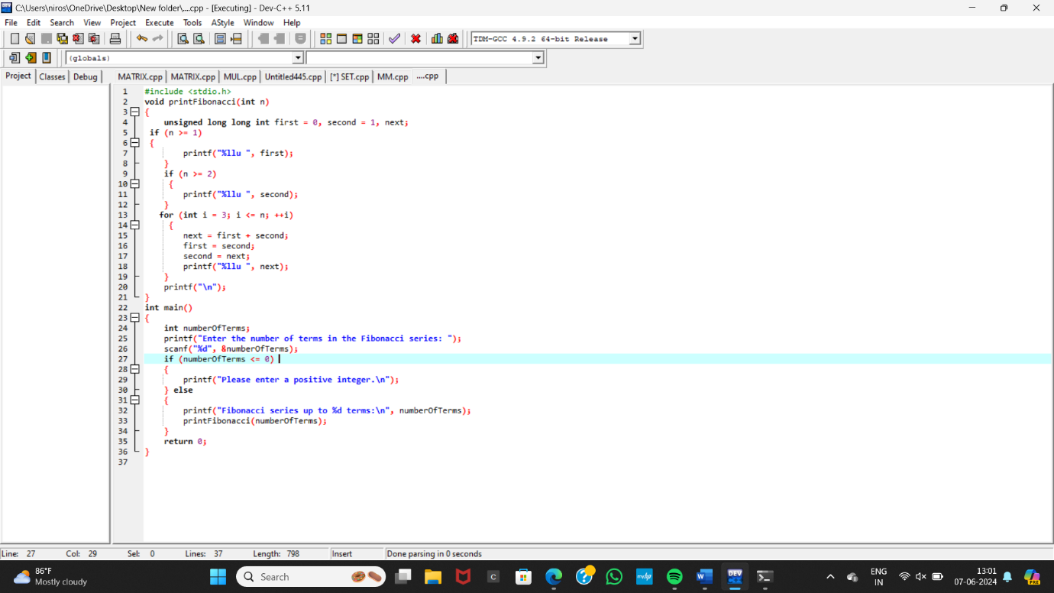

**OUTPUT:**

